Answer the Following questions:

1. Answer the following questions:

a. Briefly discuss (i.e. in 2-4 statements or sentences) each of the following terms:

i. Data:

Data is a piece or collection of facts or figures that is gathered through scientific method(a generic term I use to refer to observation and measurement) for a the purpose of referencing and/or analysis.

ii. Database: A *database* is a set of data stored in a computer. This data is usually structured in a way that makes the data easily accessible.

iii. Database Management system: DBMS is a software that people use to manage, control and implement operations of a database. It consists of **a group of** (collection) of programs which manipulate the database.

iv. Database application program: DBAP are software programs designed to collect, manage and disseminate information efficiently.

b. Describe the main characteristics of the Data approach and contrast it with the File-based approach.

|  |  |
| --- | --- |
| File-Based Approach | Database approach |
| * Might include physical Files set up to hold data related to a project, task, client | * It is a single, usually large repository of data that can be used by many departments and users. |
| * Files are labeled and stored in one or more filing cabinets. Results in separation of and insolation of | * The database is no longer owned by one department but is a shared corporate resource |
| * When some info is needed the user goes to the filing system & searches through | * the self-describing nature of a database that provides program–data independence. |
| * Duplication is apparent | * Instead of disconnected files with redundant data, all data items are integrated with a minimum amount of duplication. |
| * A file is simply a collection of records, which contains logically related data | * A Database, more formally, can be defined as a shared collection of logically related data and its description, designed to meet the information needs of an organization. |

c. What are the five components of the DBMS environment and how are

they related to each other?

The Five components of DBMS environment are

Hardware, software, Data, Procedures and people

* Hardware: the DBMS require hardware to run. This can be a single personal computer or a large Mainframe computer or a network of servers.
* Software: The software component comprises the DBMS software itself and the application programs, together with the operating system, including network software if the DBMS is being used over a network.
* the data acts as a bridge between the machine components and the human components.
* Procedures: This refers to the instructions and rules that govern the design and use of the database.
* People: means the people or roles involved with the Database system.

1. study the Dream Home case study introduced/presented in this Lesson.

1. And answer the following questions:

i. What do you think are the main objects that need to be represented in the database?

**Property Owner property for Rent, Client, Stuff**

ii. What relationships do you think exist between these main objects?

Private owner rents property

Client view property

Client can ( hold lease) of property

Stuff Manages property.

iii. For each of the objects, what details do you think need to be stored in the database?

**Property**

* Property Id
* Property owner’s name
* Property Address
* Property value
* Lease Duration

**Property Owner**

-Owner ID

-Owner Address

-Owner Age

-Owner Gender

**Client**

* Client ID
* Client Age
* Client Gender
* Client SSN
* Client Credit score
* Client Income
* Client occupation

**Stuff**

* Stuff ID
* Stuff Branch
* Stuff Responsibility
* Stuff Name

iv. Give at least 3 queries you think will be required.

* **What are the addresses of clients who are in Lease ?**
* **Which properties are leased for more than a year?**
* **What is the average income of the client who leased the private properties?**

1. MySQL JS > \status

2. MySQL JS > \connect root@localhost

MySQL JS > \sql

SQL > show databases;

use world;

SQL > show tables;

desc country;

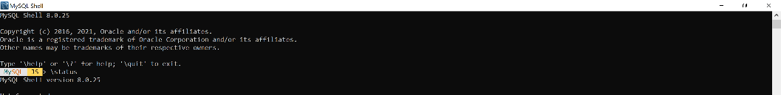ity;

